**Website:**

**https://nepstate.com/**When you visit website you will see header containing some options. Let us discuss all one by one.

**Home:**This is the main landing page of website. Here you will see two buttons.  
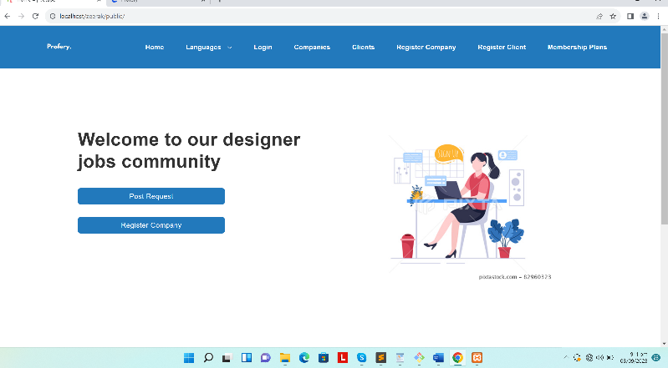  
First is **Post Request**:  
This button will be used if someone want to create a request. When you press it system will check whether the user is logged in or not. If not than it will take to the registration page of client. If yes than it will show a dropdown so that you can select category and by pressing Post request It will take to the request form.  
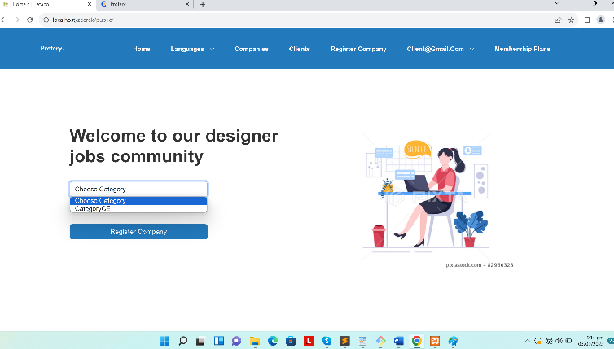  
Now question is why category is selected? Because this category will decide which questions will be asked while creating request. First it will ask some basic questions than it will take to the second form which is questions.  
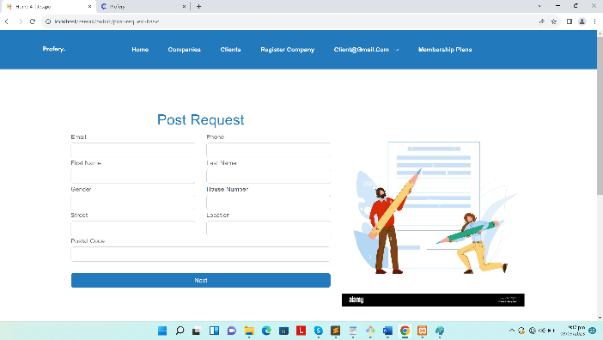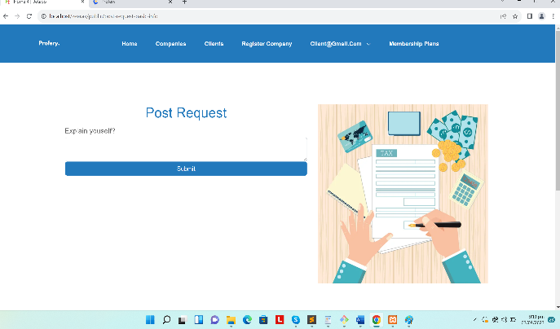  
By answering them request will be created successfully.  
Second is **Register Company**:  
This button will be used if someone want to register company. It will take to the register form.  
First It will ask basic questions including category.  
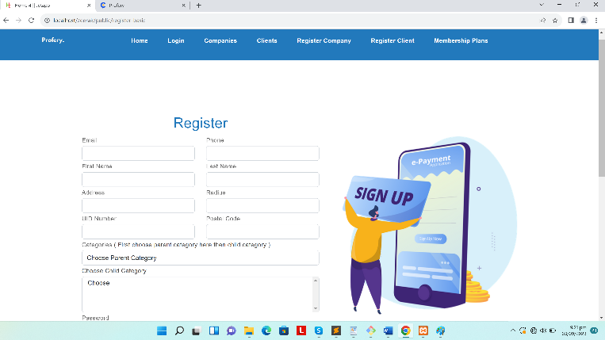  
Now question is why category because It will decide which questions will be asked than It will take to next step which is the form of questions. You can see there is dropdown called categories you have to select parent category. On selecting any category the dropdown of child category will be populated so than you have to select child category as many as you want by pressing ctrl 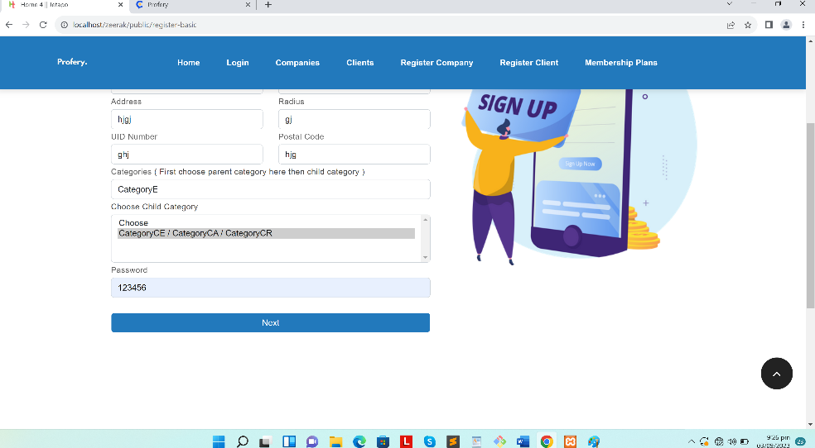

By pressing next button It will take to the next step which is answering questions.  
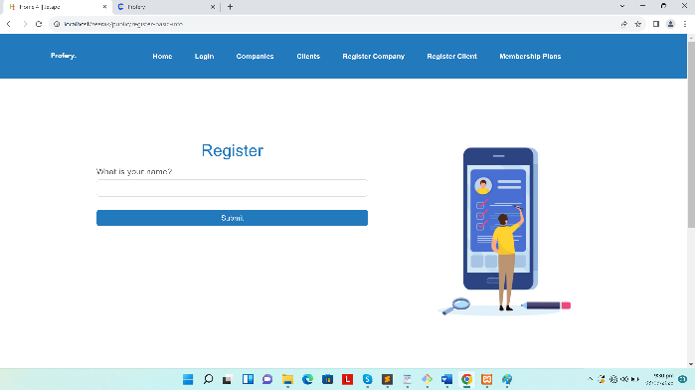  
When you press submit than it will take you to the screen of google map.  
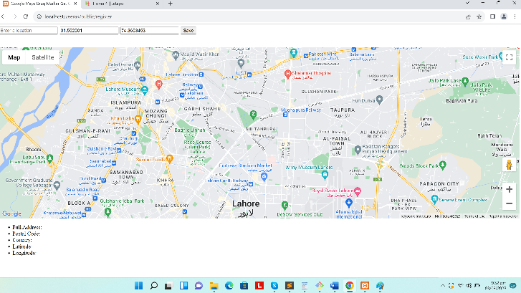  
It contains input field in which you can find any place. On submitting this, company will be created successfully.

**Languages:**This is actually a dropdown. It contains three languages options. This dropdown will be shown on home screen. All content on the website will change according to that.  
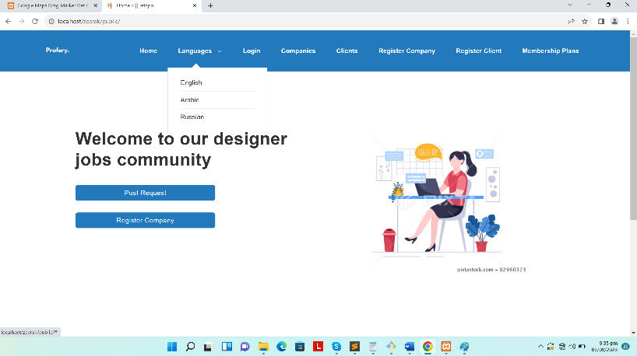

**Login:**This button will be used if someone want to login. Company owner and client both can login.  
  
Let’s logout and login with company that I have already created for you using email: [company@gmail.com](mailto:company@gmail.com) and password: 123456   
You will see a dropdown in the header. It will contain four options. Let’s discuss one by one.  
**Update Company Profile:**  
When you click on this it will take you to the form by which you can update company profile.  
**All Requests:**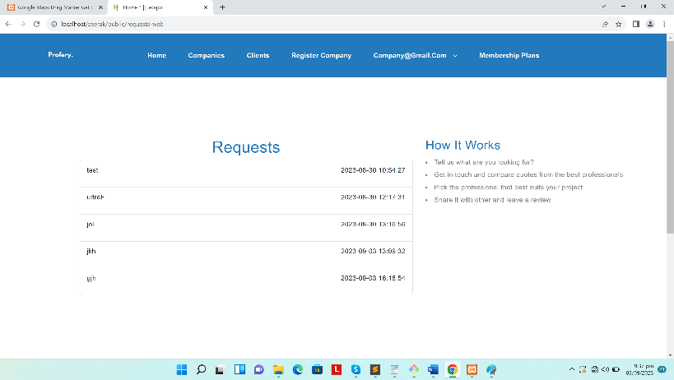  
This will show a list of requests. You can also see detail of all requests. Now question is how many requests will be shown. Answer is It will depend upon the membership plan. You can see detail of request as well by clicking name or date.  
**My Requests:**  
This will show the list of requests that was created by company itself. You can see detail of request as well.  
**Logout:**  
Using this button company owner can logout.  
  
Now let’s logout and login with client that I have already created for you using email: [client@gmail.com](mailto:client@gmail.com) password: 123456  
You will see a dropdown in the header which contains:  
**My Requests**:  
It will show all requests that were created by client. You can see details of request as well.  
On the **home** screen you can see small form will be shown having button of Post Request. It will take you to the request form. Which contains two steps that I mentioned above.  
  
**Companies:**It will show the list of companies.  
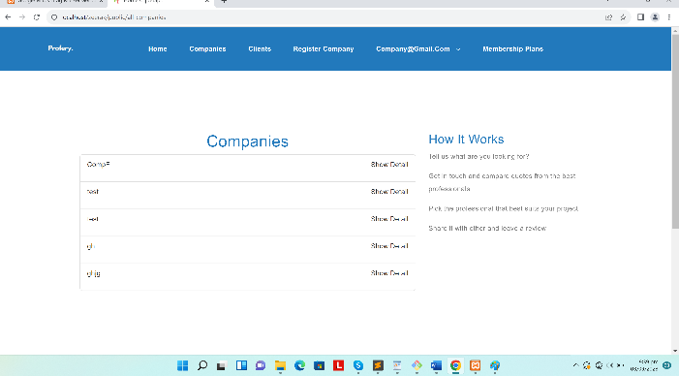

You can see detail as well by pressing show detail button. On the detail screen you will see a detail of company and all reviews of company.  
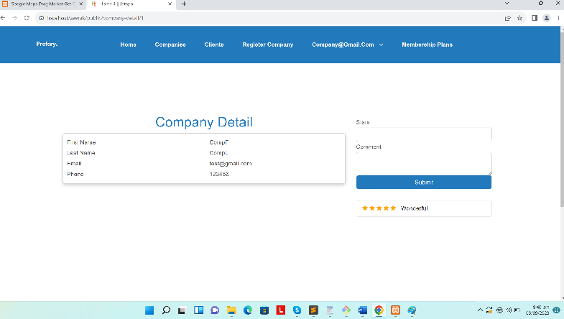

If you are logged in as client than you will see a form for rating company. It will ask stars and comment than you can submit.

**Clients:**It will show the list of clients.  
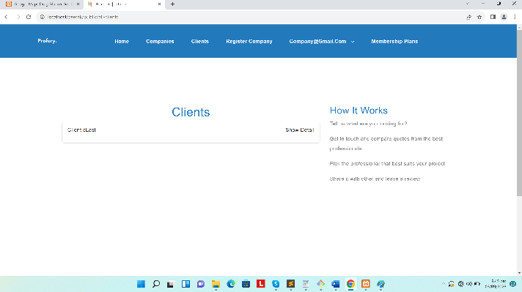

You can see detail as well by pressing show detail button. On the detail screen you will see a detail of company and all reviews of company.  
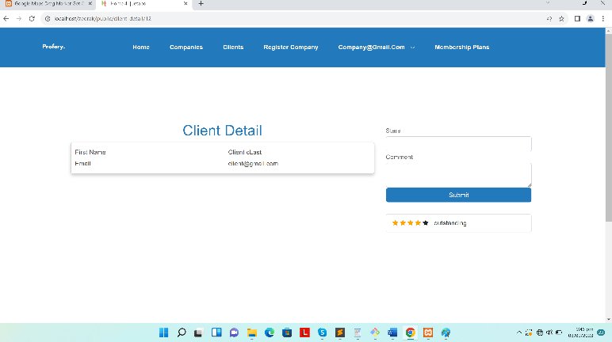  
 If you are logged in as company than you will see a form for rating client. It will ask stars and comment than you can submit.  **Register Company:**This will take you to the registration form. First It will ask some basic details than It will take to the step 2 and ask questions than It will take to the google maps screen I have already mentioned complete process above.

**Register Client:**This will take you to the client registration form. By filling it client will be created successfully.  
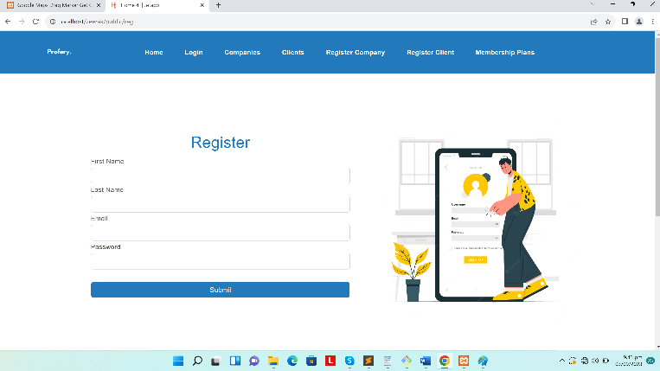  
  
**Membership Plans:**It will take to the screen in which you see all membership plans than were created by super admin. On each plan you will see a button of subscribe. On pressing it. This will take to the payment screen of stripe.  
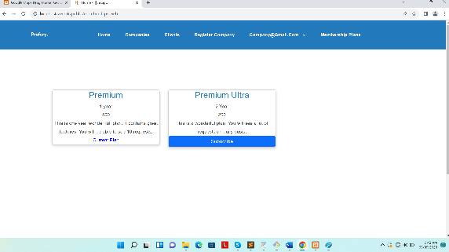  
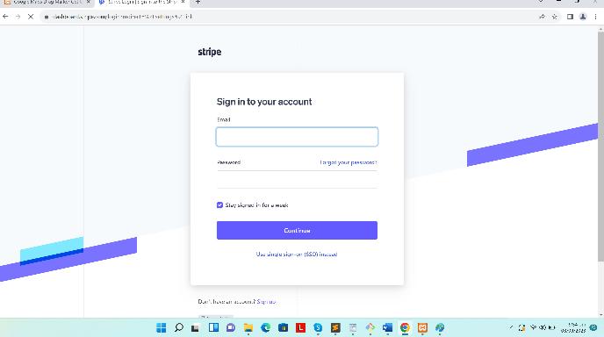

**Admin Panel:**

**https://nepstate.com/admin-panel/**  
Firstly you need to login as a super admin for accessing all options of admin panel  
Lets login with email: [superadmin@gmai.com](mailto:superadmin@gmai.com) password: 123456   
When you login you will see navigation drawer. It contains some options. Let’s discuss all one by one.

**Categories:**  
This section has CRUD (Create, Read, Update, Delete) options. This contains two main fields:  
name (all languages) and parent category (every category can belong to some parent category, if you want to create parent category itself then you must leave it empty)

**Memberships:**  
This section also has CRUD (Create, Read, Update, Delete) options. This contains four fields:  
duration (1 year etc.), price (amount to pay for buying this plan) , name ,  
numberOfRequestsShown (This should be a number. Means it will decide how many requests will be shown who has bought this plan)

**Requests:**  
This section also has CRUD (Create, Read, Update, Delete) options. This contains category (all child categories will be shown in a dropdown menu), postal Code, location, street, houseNo, gender, firstName, lastName, phone, email. In the table you will see column of CreatedBy; This will show who created this request. You will also see column of answers ; this will show all answers that was provided while creating request. You will also see column of provide answers ; This will allow you to provide answers for request if super admin created request by own.

**Companies:**  
This section also has CRUD (Create, Read, Update, Delete) options. This contains categories (all child categories will be shown here in a dropdown. You can select multiple categories by pressing ctrl. Please tell me if you don’t know how to select multiple categories), firstName, lastName, phone email, password, postal code, address , radius (number), uidNumber. In the table you will see column of location; here two options will be shown one is provide; with the help of this you can provide location. Second option is Update; for updating location of a company. In the table you will see option of answers; This will show all answers that was provided while creating company through website. In the table you will also see option of membership plan; this will tell by which plan this company associated with. With the help of edit feature you can update membership by editing company. You will do this when company will buy membership plan and you need to activate than plan for company.

**Clients:**   
This section only has read option. You will see all clients that were created through website. In the table you will see column of requests; By this you can see all requests that was generated by specific user.

**Questions (Company):**  
This section also has CRUD (Create, Read, Update, Delete) options. This contains category (all child categories will be shown in dropdown), question (of all languages), inputType (This contains four option; text (for text input), textArea (for large input area), File (for showing file input field), checkboxes (for showing checkboxes as a input)), Checkboxes (in all languages); Important note is that you can provide multiple checkboxes labels by separating with semi colon e.g.: if you want to add two checkboxes like “yes” and “no”, then you will write “yes;no”. Please ask if you have any confusion regarding this. All these questions will be shown when someone create company on a website.

**Questions (Requests):**  
This section also has CRUD (Create, Read, Update, Delete) options. This contains category (all child categories will be shown in dropdown), question (of all languages), inputType (This contains four option; text (for text input), textArea (for large input area), File (for showing file input field), checkboxes (for showing checkboxes as a input)), Checkboxes (in all languages); Important note is that you can provide multiple checkboxes labels by separating with semi colon e.g: if you want to add two checkboxes like “yes” and “no”, then you will write “yes;no”. Please ask if you have any confusion regarding this. All questions will be shown when someone create request on a website.

**Logout:**On the header you will see a dropdown on the top right. It contains option of logout. So let’s logout and move to website.